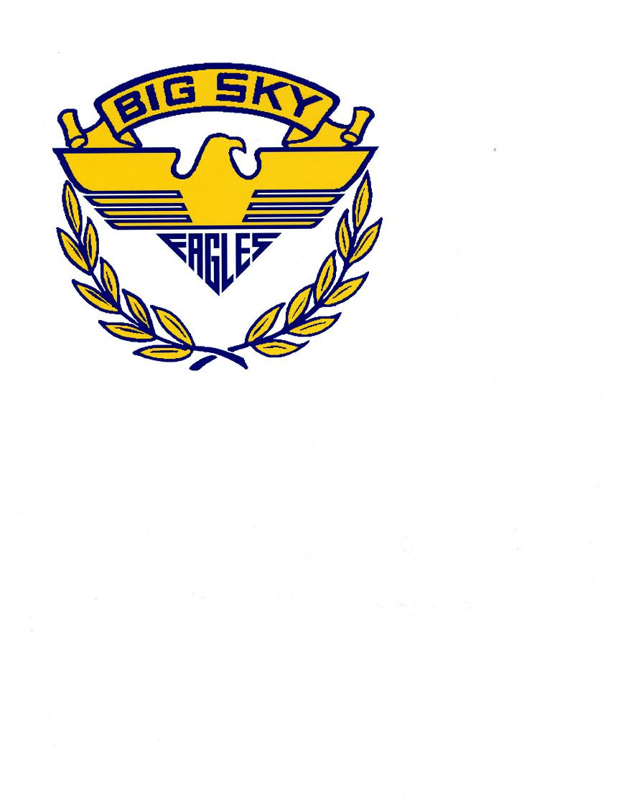

BIG SKY CHOIR CALENDAR
2022-23

Please make note of the following choral events for this year. Every effort must be made to check for possible conflicts previous to each event. Highlighted dates are graded events in which every BSHS choir student will participate. Please put these dates in your calendar NOW!

DATE DAY EVENT TIME

Oct 11 TUES Fall Concert 7:00 PM
Oct 19-21 Wed – Fri All-State Band, Orch, Choir – Bozeman All Day/Night

Nov 14-15 Mon–Tues AA Choral Fest (Aesirian) - Big Sky All Day/Night

Dec 9 Fri Ugly Sweater Tour (Sky Blues) During School

Dec 20 TUES Winter Concert – All Choirs 7:00 PM

Jan 20-22 Fri-Sun All Star Honor Choir – UM TBA

Feb 16-18 Thur – Sun All-NW NAfME in Bellevue, WA TBA
Feb 25 Saturday Dessert Show – All Choirs 7:00 PM

April 4 Tues Festival Concert – All Choirs 7:00 PM
Apr 12-13 Tues/Wed District II Music Festival – Sent HS During Class
Apr 15 Sat District II Music Festival – BSHS All Day

May 5-6 Fri/Sat State Music Festival – Missoula/UM TBA

May 16 Tues All Choirs – Final Concert/ Awards 7:00PM

Jun 3 Saturday Graduation – Aesirian Choir TBA

